In section [2.2.2], it is illustrated that there are 2 circuitries that could be used for the wind vane: a current mirror and a voltage divider. For simplicity, the latter is utilised in this project.

In order to form a voltage divider, an external resistor as shown in [Figure ? – section 2.2.2] is required. The value of a such component in turn needs to satisfy that:

* Current output at the voltage divider is enough for the ADC module to charge its internal capacitor CADC for each conversion.
* Voltage step of the voltage divider values generated by all the wind vane positions is large enough for the microcontroller to distinguish.

Figure 1 illustrates the voltage divider circuit when integrated with the microcontroller’s ADC module. It is assumed that at the beginning of each conversion cycle, the internal capacitor CADC has been fully discharged and the switch (“SW”) is then closed.

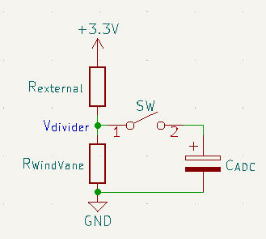

Figure 1. Voltage divider circuitry with ADC module

By applying the source transformation technique, the voltage divider could be changed into a first order RC charging circuit as shown in Figure 2. The Norton equivalent circuit is produced by deriving a Thévenin equivalent circuit of the +3.3V voltage source in series with the resistor *Rexternal*, which yields:

|  |  |  |
| --- | --- | --- |
|  |  | () |

The resulted circuitry is then further simplified by combining the parallel resistors into a single value:

$$R_{equivalent}=\frac{R_{external}×R_{WindVane}}{R_{external}+R_{WindVane}}$$

At this point, the step response of an RC circuit as given by [1] could be applied:

|  |  |  |
| --- | --- | --- |
|  | $$v_{C_{ADC}}=I_{S}×R_{equivalent}+\left(V_{0}-I_{S}×R_{equivalent}\right)×e^{{-t}/T}, t≥0$$ | (2) |

or, based on previously made assumption, and by substituting (1) into (2):

$$v_{C_{ADC}}=I_{S}×R_{equivalent}×(1- e^{{-t}/T}), t≥0$$

where $T=R_{equivalent}×C_{ADC}$ is the time constant for the RC circuit. It is worth noticing that the voltage up to which the capacitor CADC is charged is:

$$V_{divider}=I_{S}×R_{equivalent}=3.3V×\frac{R_{WindVane}}{R_{external}+R_{WindVane}}$$

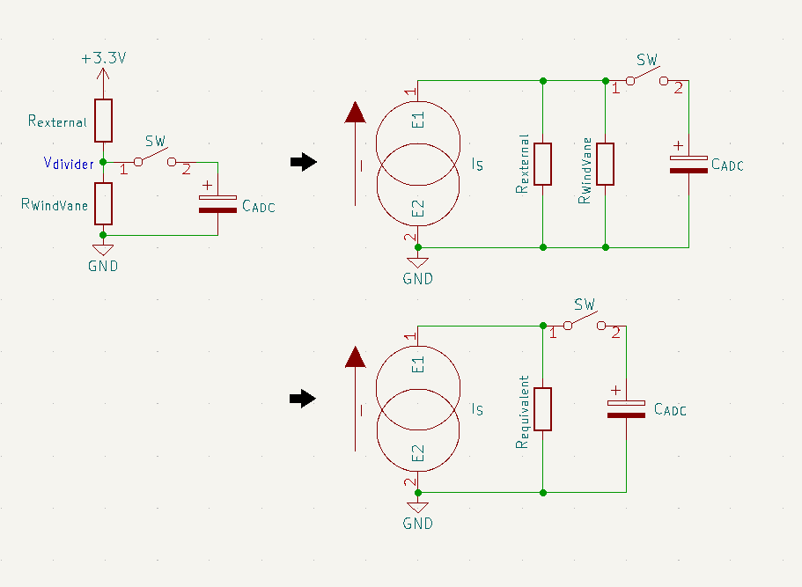

Figure 2. Derivation of the Norton equivalent of the voltage divider

According to the capacitor charging voltage curve shown in [2], CADC would reach its steady state within 4*T* after the switch is closed, and become fully charged at t = 5*T*. It is desirable that the ADC internal capacitor CADC is fully charged during the sampling window of the ADC module. Since the lowest sample rate of the STM32F103CBT6 microcontroller is 1.5 ADC clock cycles [3], there holds a condition for *Rexternal*:

|  |  |  |
| --- | --- | --- |
|  |  |  |
| => |  |  |
| => |  |  |

This project uses an STM32F103CBT6 micrcontroller on the official Arduino core by STMicroelectronics, so the ADC clock frequency could be derived to be 12MHz from the core project on Github [4]. Furthermore, [5] specifies that the internal sample and hold capacitor of the ADC module is guaranteed to be 8pF by design. By substituing the wind vane internal resistance values from [table? – section 2.2.2], the condition of $R_{external}≤3.208kΩ$ is obtained. Afterward, all the manufactored resistor values which meet that condition are put into an Excel sheet to calculate the corresponding voltage step of the voltage divider with a fixed value of +3.3V power supply.

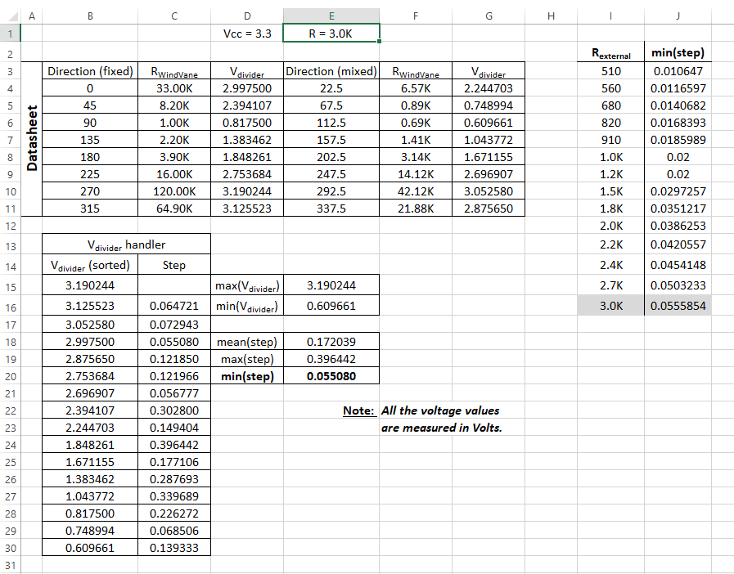

Figure 3. An instance of Rexternal = 3.0kΩ input to the voltage step-calculating sheet

Table 1 records all the minimum voltage steps of the voltage divider for all the resistor values under 3.208kΩ. Since the STM32F103CBT6 microcontroller has 12-bit ADC modules, in theory, it could detect analogue input changes as low as $\frac{3.3V}{2^{12}}=805.7μV$. Therefore, all voltage steps in Table 1 is detectable. However, in practice, there are a number of factors like ADC offset errors, input noise, imprecise analogue reference, etc. that could cause unpredictable behaviours and/or unusable data if an ADC module were applied in ideal conditions. As a result, the largest voltage step by design for an ADC module to detect is always desired, which is 0.0555854V for Rexternal = 3.0kΩ.

|  |  |
| --- | --- |
| **Rexternal (in Ohms)** | **Voltage step (in volts)** |
| 510 | 0.010647 |
| 560 | 0.0116597 |
| 680 | 0.0140682 |
| 820 | 0.0168393 |
| 910 | 0.0185989 |
| 1.0K | 0.02 |
| 1.2K | 0.02 |
| 1.5K | 0.0297257 |
| 1.8K | 0.0351217 |
| 2.0K | 0.0386253 |
| 2.2K | 0.0420557 |
| 2.4K | 0.0454148 |
| 2.7K | 0.0503233 |
| 3.0K | 0.0555854 |

Table 1. Voltage steps of the voltage divider by Rexternal

[1] J. W. Nilsson and S. A. Riedel, “The Step Response of RL and RC Circuits,” in *Electric Circuits*, 10th ed., Pearson Education, Inc., 2015, pp. 224–231.

[2] Electronics Tutorials Team, “RC Charging Circuit.” https://www.electronics-tutorials.ws/rc/rc_1.html.

[3] STMicroelectronics, “STM32F101xx, STM32F102xx, STM32F103xx, STM32F105xx and STM32F107xx advanced Arm®-based 32-bit MCUs,” no. February 2021. 2021.

[4] STMicroelectronics, “Arduino_Core_STM32.” [Online]. Available: https://github.com/stm32duino/Arduino_Core_STM32.

[5] STMicroelectronics, “STM32F103x8, STM32F103xB.” pp. 1–116, 2022.